**Import and Combine Multiple PDF Pages into a Single Document**

The Syncfusion Essential [.NET PDF library](https://www.syncfusion.com/document-processing/pdf-framework/net/pdf-library) is is a powerful tool for creating, reading, and editing PDF documents programmatically, without relying on Adobe products. It enables you to import, merge, split, and secure PDFs easily. In this guide, we will show you how to import pages from multiple PDF documents and combine them into one using C# and VB.NET.

**Steps to Import and Combine PDF Pages Programmatically**

1. Create a new C# console application project.

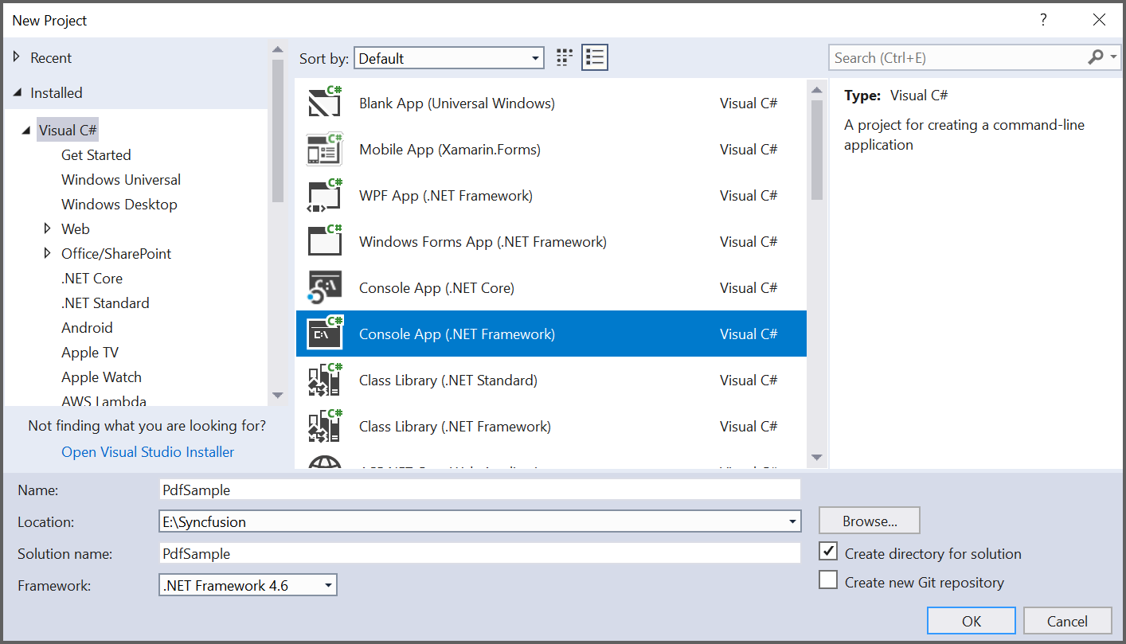

2.

Install the **[Syncfusion.PDF.WinForms](https://www.nuget.org/packages/Syncfusion.PDF.WinForms/" \t "_blank)** NuGet packages as a reference to your .NET Framework application from [**NuGet.org**](https://www.nuget.org/).

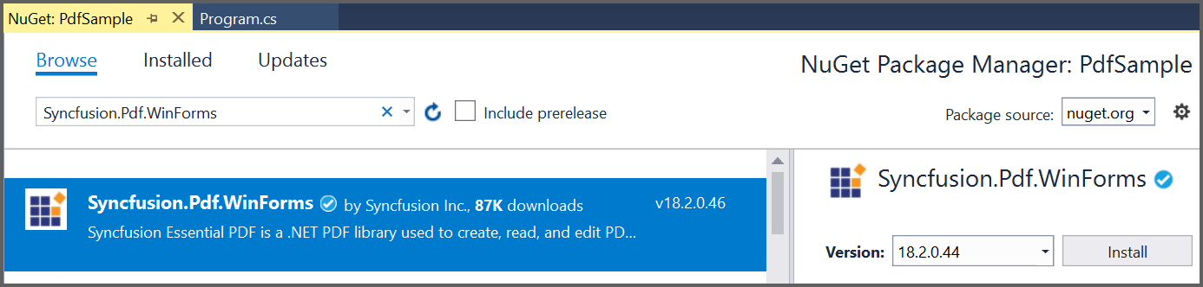

3. Include the following namespaces in the Program.cs file.

**C#**

**using** Syncfusion.Pdf;

**using** Syncfusion.Pdf.Graphics;

**using** Syncfusion.Pdf.Parsing;

**VB.NET**

**Imports** Syncfusion.Pdf

**Imports** Syncfusion.Pdf.Graphics

**Imports** Syncfusion.Pdf.Parsing

**4.** The following code example shows how to import pages from multiple PDF documents to one PDF document at a specific page range using C#.

**C#**

// File paths

string inputFile1 = "Brochure.pdf";

string inputFile2 = "Barcode.pdf";

string outputFile = "Sample.pdf";

// Load the PDF documents using 'using' statement to ensure proper disposal

using (PdfLoadedDocument loadedDocument1 = new PdfLoadedDocument(inputFile1))

using (PdfLoadedDocument loadedDocument2 = new PdfLoadedDocument(inputFile2))

using (PdfDocument document = new PdfDocument())

{

// Import pages from the documents

document.ImportPageRange(loadedDocument1, 0, 1); // Import specific pages from the first document

document.ImportPageRange(loadedDocument2, 0, loadedDocument2.Pages.Count - 1); // Import all pages from the second document

document.ImportPageRange(loadedDocument1, 2, loadedDocument1.Pages.Count - 1); // Import remaining pages from the first document

// Save and close the document

document.Save(outputFile);

}

**VB.NET**

' File paths

Dim inputFile1 As String = "Brochure.pdf"

Dim inputFile2 As String = "Barcode.pdf"

Dim outputFile As String = "Sample.pdf"

' Load the PDF documents ensuring proper disposal

Using loadedDocument1 As New PdfLoadedDocument(inputFile1),

loadedDocument2 As New PdfLoadedDocument(inputFile2),

document As New PdfDocument()

' Import pages from the documents

document.ImportPageRange(loadedDocument1, 0, 1) ' Import specific pages from the first document

document.ImportPageRange(loadedDocument2, 0, loadedDocument2.Pages.Count - 1) ' Import all pages from the second document

document.ImportPageRange(loadedDocument1, 2, loadedDocument1.Pages.Count - 1) ' Import remaining pages from the first document

' Save and close the document

document.Save(outputFile)

End Using

By executing this program, you will efficiently import and combine PDF pages.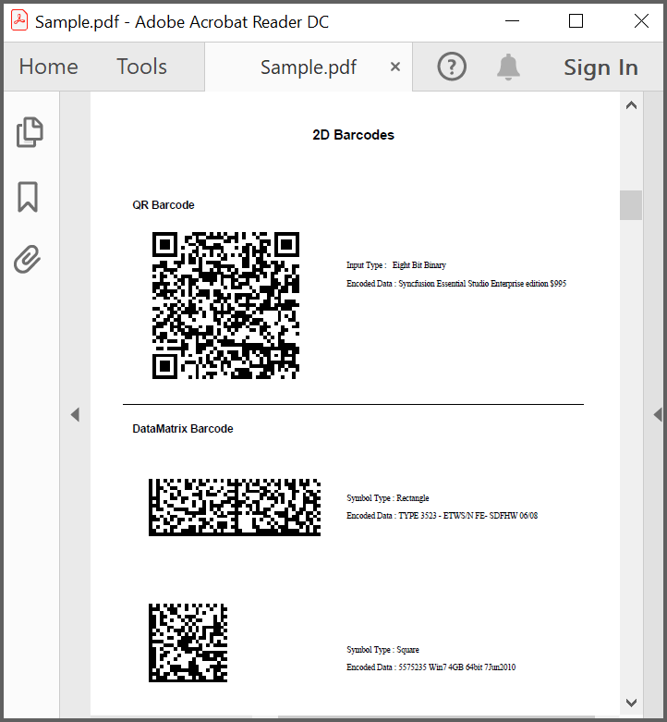

A complete working sample can be downloaded from [**PdfSample.zip**](https://www.syncfusion.com/downloads/support/directtrac/general/ze/PdfSample2029966632).

Take a moment to peruse the documentation for [**working with pages**](https://help.syncfusion.com/file-formats/pdf/working-with-pages). You can find the options like inserting, rotating, importing, and rearranging the pages from an existing document, removing the pages, and splitting a PDF file to individual pages.

Refer to [**here**](https://www.syncfusion.com/document-processing/pdf-framework/net)to explore a rich set of Syncfusion Essential® PDF features.

Note:

Starting with v16.2.0.x, include a valid Syncfusion® license key in your projects. Refer to [this link](https://help.syncfusion.com/common/essential-studio/licensing/overview) for more details.

**Conclusion**

We hope this guide helps you understand how to import and combine multiple PDF pages into a single document using C# and VB.NET.

You can refer to our  [**.Net Pdf feature tour**](https://www.syncfusion.com/document-processing/pdf-framework/net/pdf-library) page to know about its other groundbreaking feature representations. You can also explore our [**documentation**](https://help.syncfusion.com/file-formats/pdf/create-pdf-file-in-c-sharp-vb-net) to understand how to create and manipulate data.

For current customers, you can check out our components from the [**License and Downloads**](https://www.syncfusion.com/sales/teamlicense) page. If you are new to Syncfusion, you can try [**support forums**](https://www.syncfusion.com/forums) our 30-day [**free trial**](https://www.syncfusion.com/downloads/pdf)to check out our other controls.

If you have any queries or require clarifications, please let us know in the comments section below. You can also contact us through our, [**Direct-Trac**](https://support.syncfusion.com/create), or[**feedback portal**](https://www.syncfusion.com/feedback/aspnet-core?control=pdf). We are always happy to assist you!